


In Memory of
Able Seaman DAVID NOBLE
207466, (RFR/PO/B/2136). H.M.S. "Alcantara.", Royal Navy
who died age 35
on 29 February 1916
Husband of Jane Noble, of 7, George St., Macduff, Banffshire.
Remembered with honour
PORTSMOUTH NAVAL MEMORIAL
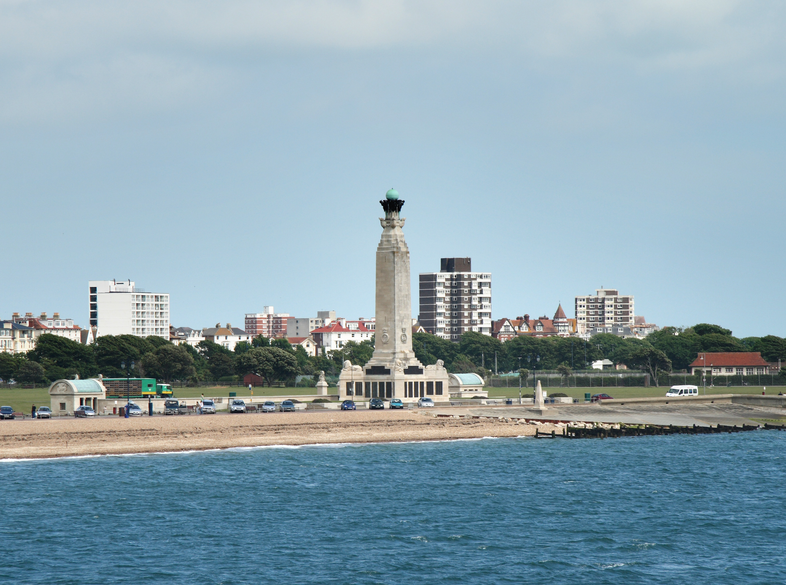
Commemorated in perpetuity by
the Commonwealth War Graves Commission

